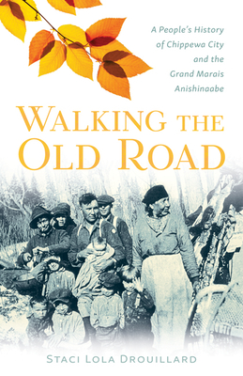

**Reading Schedule**

We will be discussing the following chapters on the following dates:

**January 16: Prologue & Chapters 1–2**

**January 23: Chapters 3–5**

**January 30: Chapters 6–7**

**February 6: Chapters 8–10**

**February 13: Chapters 11–13 & Epilogue**

| ***Walking the Old Road* by Staci Lola Drouillard**  Prologue THE LONG ROAD (1-6)  Chapter 1 WE USED TO SNEAK IN THERE AND PLAY: The Chippewa City Church  (9-23)  Chapter 2 A GATEWAY FOR THE AGES: The Anishinaabeg Arrive at the Pigeon  River (25-50)  Chapter 3 AT THE PLEASURE OF THE UNITED STATES: The Land Changes Hands  (53-68)  Chapter 4 HERE WERE MANY WIGWAMS: The Grand Marais Chippewa (71-97)  Chapter 5 NISHKWAKWANSING: At the Edge of the Forest (99-112)  Chapter 6 NOKOMISAG MIINAWAA MISHOOMISAG: Grandmothers and  Grandfathers (115-140)  Chapter 7 INDIAN MAIDENS AND PLASTIC TOMAHAWKS: How to Make a Living  (143-168)  Chapter 8 A CALL FROM LONGBODY: North Woods Neighbors (171-191)  Chapter 9 WE ARE BURIED HERE: The Old Cemetery (193-207)  Chapter 10 I GUESS SOMETIMES I’M TORN: Life between Two Worlds (209-223)  Chapter 11 DIVIDE THE LAND, DIVIDE THE PEOPLE: Land and Identity (225-241)  Chapter 12 SIGNED WITH AN X: Katie’s Point (243-253)  Chapter 13 JIGEWAYAAZHAGAMAY: She Walks along the Water’s Edge (255-266)  Epilogue A RETURN HOME (269-276) |
| --- |

As you read, write down questions. Mark significant passages. Or, just soak it in. There is no pressure to contribute to the discussion. Just be mindful of the space you use if you choose to share - we want all voices to have the opportunity to be heard. This is a safe space to enter the conversation, regardless of previous knowledge or experience. Let’s learn and grow from and with each other!